Stacked Bar Chart

Definition
# Source: AI Source: Provided by: [Data Path: Persons Table -> ID Column: 1, Name_En Column: Motasem Essam] -> From: [Chatgpt (GPT‑5 Mini)] on [12/10/2025]
A Stacked Bar Chart is a type of bar chart where values of subgroups are stacked on top of each other in a single bar for each main category. The total length of the bar represents the sum of all subgroups.

Key Idea
# Source: AI Source: Provided by: [Data Path: Persons Table -> ID Column: 1, Name_En Column: Motasem Essam] -> From: [Chatgpt (GPT‑5 Mini)] on [12/10/2025]
Stacked bar charts are used to show the composition of each category while also allowing comparison of totals across categories. Each segment of the bar represents a subgroup within the main category.

How It Works
# Source: AI Source: Provided by: [Data Path: Persons Table -> ID Column: 1, Name_En Column: Motasem Essam] -> From: [Chatgpt (GPT‑5 Mini)] on [12/10/2025]
- Identify the main categories for the x-axis.
- Identify subgroups within each category.
- Stack the subgroup values on top of each other for each category.
- Use different colors for each subgroup to differentiate them.

Example
# Source: AI Source: Provided by: [Data Path: Persons Table -> ID Column: 1, Name_En Column: Motasem Essam] -> From: [Chatgpt (GPT‑5 Mini)] on [12/10/2025]
Dataset: Sales by Product for Two Regions
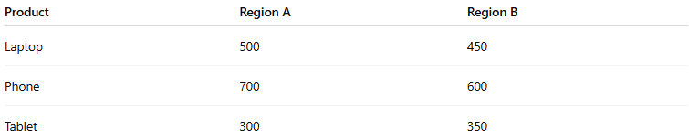
Product | Region A | Region B
Laptop | 500 | 450
Phone | 700 | 600
Tablet | 300 | 350
Stacked Bar Chart Representation:
- Each product has one bar.
- Region A sales are stacked first, Region B sales stacked on top.
- Total bar height = Region A + Region B sales.
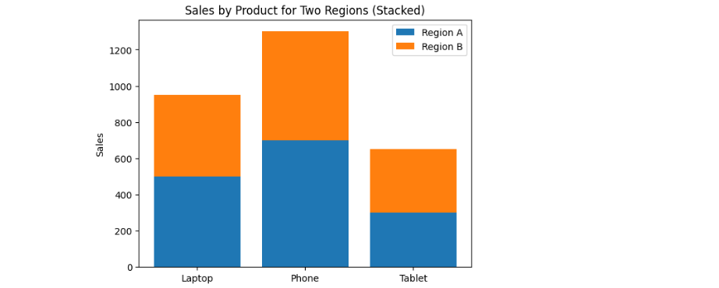

Applications
# Source: AI Source: Provided by: [Data Path: Persons Table -> ID Column: 1, Name_En Column: Motasem Essam] -> From: [Chatgpt (GPT‑5 Mini)] on [12/10/2025]
- Showing subgroup composition in each category
- Comparing totals across categories
- Visualizing survey results, sales data, or demographic distributions
- Understanding part-to-whole relationships

Advantages
# Source: AI Source: Provided by: [Data Path: Persons Table -> ID Column: 1, Name_En Column: Motasem Essam] -> From: [Chatgpt (GPT‑5 Mini)] on [12/10/2025]
- Displays both totals and subgroup contributions
- Saves horizontal space compared to grouped bars
- Effective for part-to-whole analysis

Disadvantages
# Source: AI Source: Provided by: [Data Path: Persons Table -> ID Column: 1, Name_En Column: Motasem Essam] -> From: [Chatgpt (GPT‑5 Mini)] on [12/10/2025]
- Can be hard to interpret individual subgroup sizes, especially for middle segments
- Difficult with many subgroups or small differences
- Colors must be chosen carefully to avoid confusion

